**ASSIGNMENT-25.3:**

A table named emp_salary is created with columns id, name, salary and department. And then the data is loaded into the table. The contents of the table is displayed.

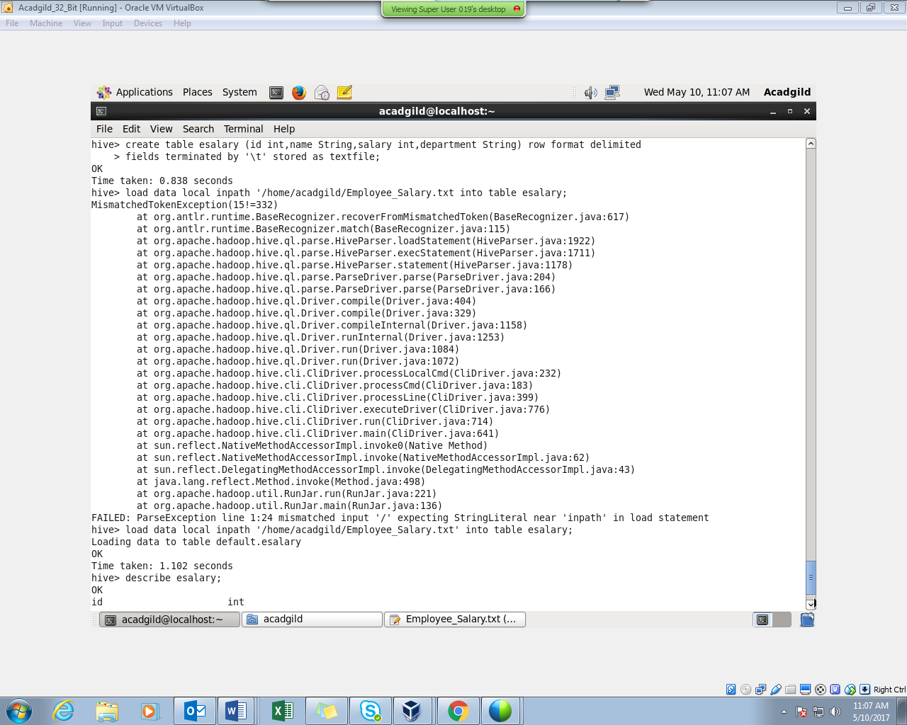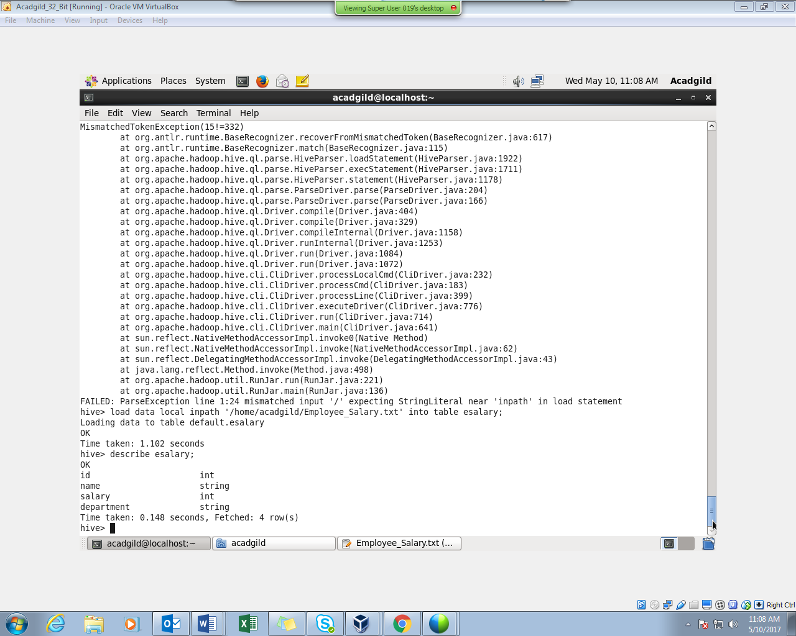

Question 1 : Get a list of employees who receive a salary less than 100, compared to their immediate employee with higher salary in the same unit

Step 1 : First we are creating a view named e_salary_vw in which a column is created by using lag function, partitioned by department and ordered by salary. This view is created as we want persons with salary less than 100 compare to immediate employee with higher salary.

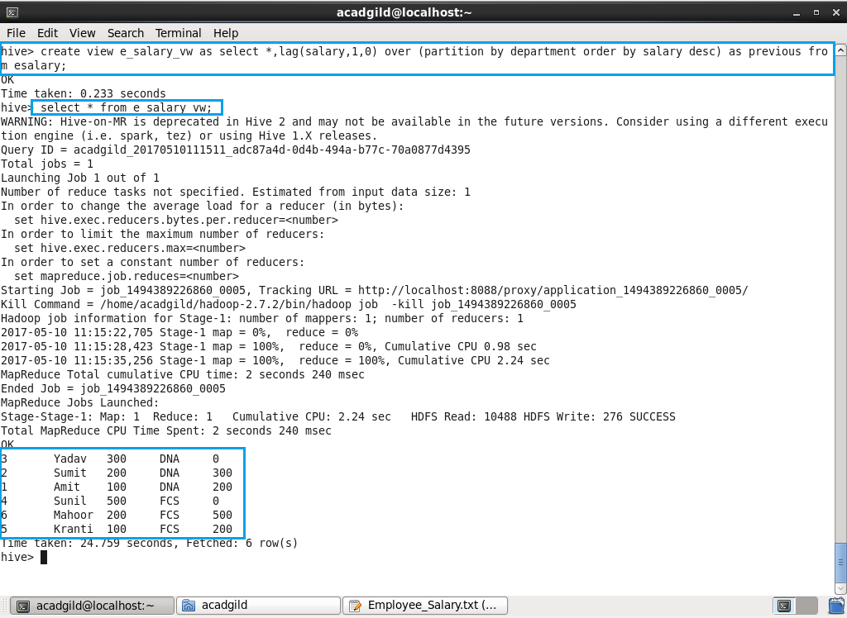

Step 2 : Here we will just filter with where clause as (previous- salary)>100

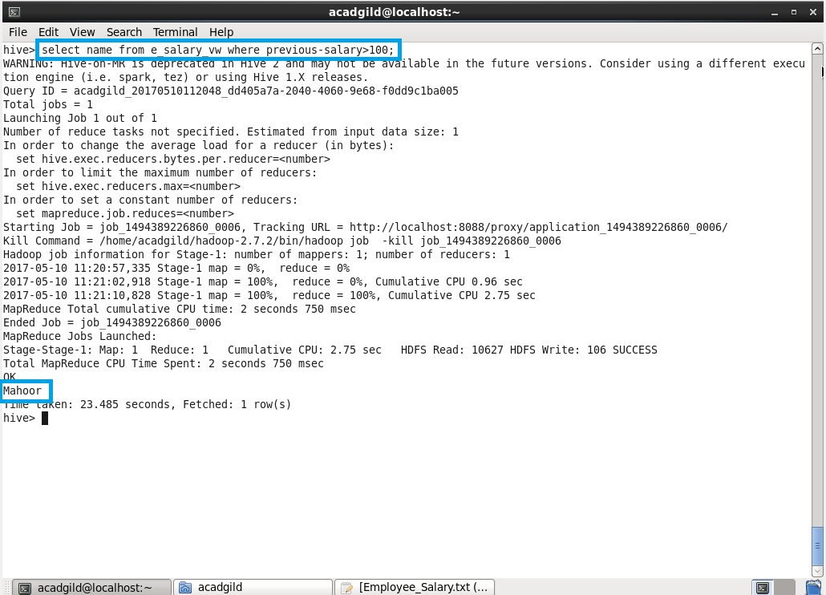

Question 2 : List of all employees who draw higher salary than the average salary of that department

Step-1: A view is created in which average salary is found department wise.

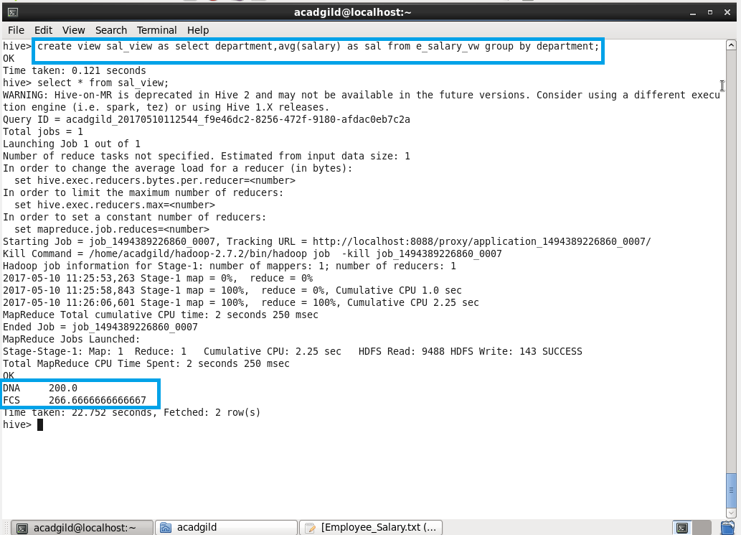

Step-2: Using join the view (e_salary_vw) and salary table is joined. This will help in finding the employees who are having salary greater than average salary.

